Ashi PO Bot

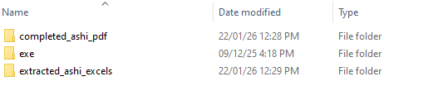
Folder Structure
Path: D:\PO-RPA\ASHI
The PO Bot works based on a specific folder structure.
Users must place their PO files at path D:\PO-RPA\ASHI with naming convention OrderType-CustomerId-PONumber.pdf

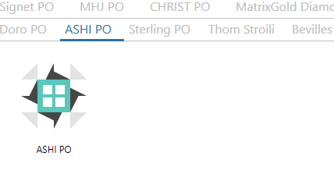
IBM RPA Launcher

- Launch the IBM RPA launcher
- Search for ASHI PO
- Double click on the button
Note: Be sure that ASHI PO should be present at location D:\PO-RPA\ASHI
- Users need to input their EMR ID press Enter and then EMR password
- Bot will extracted excel from pdf file and store at D:\PO-RPA\extracted_ashi_excels
- Bot will start running. Make sure to keep the EMR window open don’t minimize it
- Once the Data is entered into EMR, the ASHI PO will be moved to D:\PO-RPA\completed_ashi_pdf

Bevilles PO Bot

Folder Structure
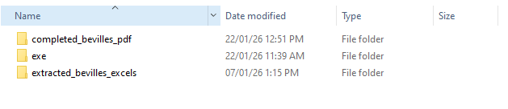
Path: D:\PO-RPA\Bevilles
The PO Bot works based on a specific folder structure.
Users must place their PO files at path D:\PO-RPA\Bevilles with naming convention OrderType-CustomerId-PONumber.xlsx

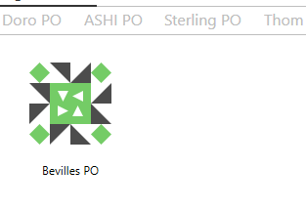
IBM RPA Launcher

- Launch the IBM RPA launcher
- Search for Bevilles PO
- Double click on the button
Note: Be sure that Bevilles PO should be present at location D:\PO-RPA\Bevilles
- Users need to input their EMR ID press Enter and then EMR password
- Bot will extracted excel from pdf file and store at D:\PO-RPA\extracted_bevilles_excels
- Bot will start running. Make sure to keep the EMR window open don’t minimize it
- Once the Data is entered into EMR, the ASHI PO will be moved to D:\PO-RPA\completed_bevilles_pdf

Christ PO Bot

Folder Structure 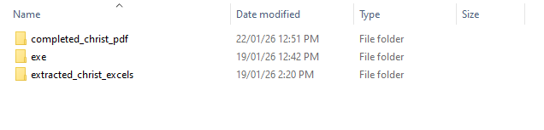
Path: D:\PO-RPA\Christ
The PO Bot works based on a specific folder structure.
Users must place their PO files at path D:\PO-RPA\Christ with naming convention OrderType-CustomerId-PONumber.pdf

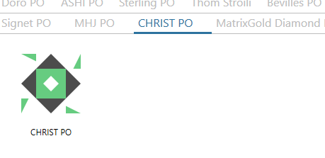
IBM RPA Launcher

- Launch the IBM RPA launcher
- Search for Christ PO
- Double click on the button
Note: Be sure that Christ PO should be present at location D:\PO-RPA\Christ
- Users need to input their EMR ID press Enter and then EMR password
- Bot will extracted excel from pdf file and store at D:\PO-RPA\extracted_christ_excels
- Bot will start running. Make sure to keep the EMR window open don’t minimize it
- Once the Data is entered into EMR, the Christ PO will be moved to D:\PO-RPA\completed_christ_pdf

Doro PO Bot

Folder Structure
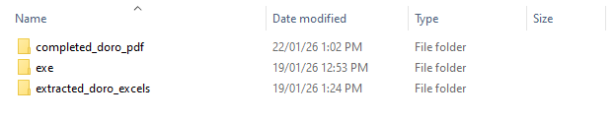
Path: D:\PO-RPA\Doro
The PO Bot works based on a specific folder structure.
Users must place their PO files at path D:\PO-RPA\Doro with naming convention OrderType-CustomerId-PONumber.pdf

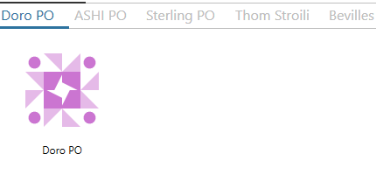
IBM RPA Launcher

- Launch the IBM RPA launcher
- Search for Doro PO
- Double click on the button
Note: Be sure that Doro PO should be present at location D:\PO-RPA\Doro
- Users need to input their EMR ID press Enter and then EMR password
- Bot will extracted excel from pdf file and store at D:\PO-RPA\extracted_doro_excels
- Bot will start running. Make sure to keep the EMR window open don’t minimize it
- Once the Data is entered into EMR, the Doro PO will be moved to D:\PO-RPA\completed_doro_pdf

FH PO Bot

Folder Structure
Path: D:\PO-RPA\FH
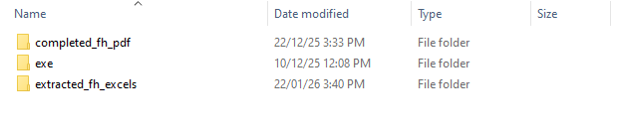
The PO Bot works based on a specific folder structure.
Users must place their PO files at path D:\PO-RPA\FH with naming convention OrderType-CustomerId-PONumber.xlsx

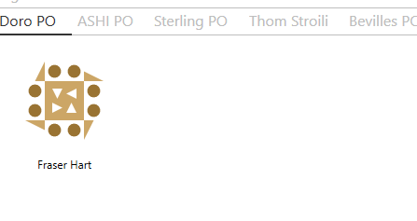
IBM RPA Launcher

- Launch the IBM RPA launcher
- Search for FH PO
- Double click on the button
Note: Be sure that FH PO should be present at location D:\PO-RPA\FH
- Users need to input their EMR ID press Enter and then EMR password
- Bot will extracted excel from pdf file and store at D:\PO-RPA\extracted_fh_excels
- Bot will start running. Make sure to keep the EMR window open don’t minimize it
- Once the Data is entered into EMR, the FH PO will be moved to D:\PO-RPA\completed_fh_pdf

LBH PO Bot

Folder Structure
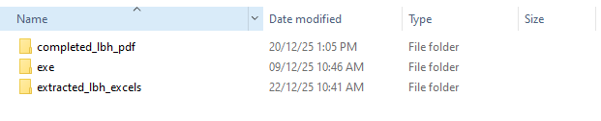
Path: D:\PO-RPA\LBH

The PO Bot works based on a specific folder structure.
Users must place their PO files at path D:\PO-RPA\LBH with naming convention OrderType-CustomerId-PONumber.pdf

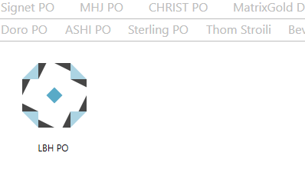
IBM RPA Launcher

- Launch the IBM RPA launcher
- Search for LBH PO
- Double click on the button
Note: Be sure that LBH PO should be present at location D:\PO-RPA\LBH
- Users need to input their EMR ID press Enter and then EMR password
- Bot will extracted excel from pdf file and store at D:\PO-RPA\extracted_lbh_excels
- Bot will start running. Make sure to keep the EMR window open don’t minimize it
- Once the Data is entered into EMR, the LBH PO will be moved to D:\PO-RPA\completed_lbh_pdf

MHJ PO Bot

Folder Structure
Path: D:\PO-RPA\MHJ
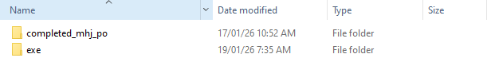
The PO Bot works based on a specific folder structure.
Users must place their PO files at path D:\PO-RPA\MHJ with naming convention OrderType-CustomerId-PONumber.xlsx

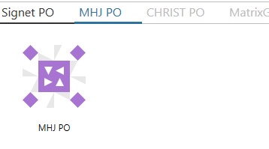
IBM RPA Launcher

- Launch the IBM RPA launcher
- Search for MHJ PO
- Double click on the button
Note: Be sure that FH PO should be present at location D:\PO-RPA\MHJ
- Users need to input their EMR ID press Enter and then EMR password
- Bot will start running. Make sure to keep the EMR window open don’t minimize it
- Once the Data is entered into EMR, the FH PO will be moved to D:\PO-RPA\completed_mhj_po
- If the pdf contains Lab Grown Diamonds, then there will be separate excel created OrderType-CustomerId-PONumber_lab_grown.xlsx
  - Rename the OrderType-CustomerId-PONumber_lab_grown.xlsx -> OrderType-CustomerId-PONumber.xlsx
  - Double click on the button
NOTE: Please add Gold, Silver, Platinum and Paladium at the end of excel manually.
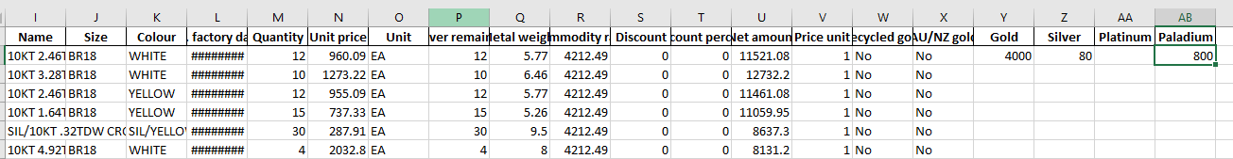

Sterling PO Bot

Folder Structure
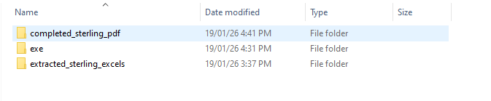
Path: D:\PO-RPA\Sterling

The PO Bot works based on a specific folder structure.
Users must place their PO files at path D:\PO-RPA\Sterling with naming convention OrderType-CustomerId-PONumber.xlsx

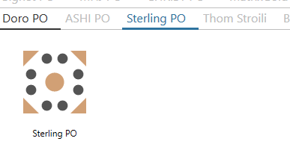
IBM RPA Launcher

- Launch the IBM RPA launcher
- Search for Sterling PO
- Double click on the button
Note: Be sure that Sterling PO should be present at location D:\PO-RPA\Sterling
- Users need to input their EMR ID press Enter and then EMR password
- Bot will extracted excel from pdf file and store at D:\PO-RPA\extracted_sterling_excels
- Bot will start running. Make sure to keep the EMR window open don’t minimize it
- Once the Data is entered into EMR, the Sterling PO will be moved to D:\PO-RPA\completed_sterling_pdf

Signet PO Bot

Folder Structure
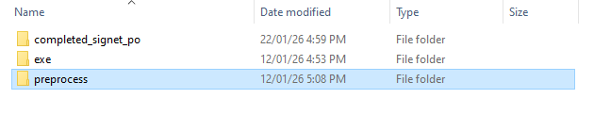
Path: D:\PO-RPA\Signet

The PO Bot works based on a specific folder structure.
Users must place their PO files at path D:\PO-RPA\Signet with naming convention OrderType-CustomerId-PONumber.xls

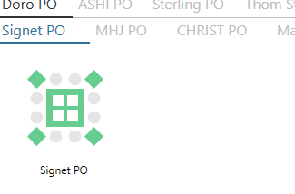
IBM RPA Launcher

- Launch the IBM RPA launcher
- Search for Signet PO
- Double click on the button
Note: Be sure that Signet PO should be present at location D:\PO-RPA\Signet
- Users need to input their EMR ID press Enter and then EMR password
- Bot will extracted excel from pdf file and store at D:\PO-RPA\preprocess
- Make sure to keep the EMR window open don’t minimize it
- Once the Data is entered into EMR, the Sterling PO will be moved to D:\PO-RPA\completed_signet_po

Thom Sas PO Bot

Folder Structure
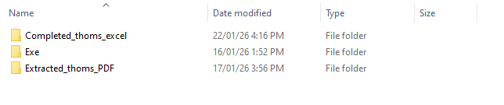
Path: D:\PO-RPA\Thoms_lr

The PO Bot works based on a specific folder structure.
Users must place their PO files at path D:\PO-RPA\Thoms_lr with naming convention OrderType-CustomerId-PONumber.pdf

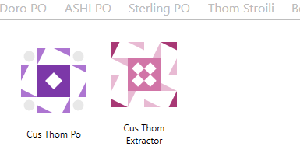
IBM RPA Launcher

- Launch the IBM RPA launcher
- Search for Cus_Thom
- There will be 2 button:
  - Cus Thom Extractor
  - Cus Thom Po
- Double click on the Cus Thom to convert PDF to Excel
Note: Be sure that Thom Sas PO should be present at location D:\PO-RPA\Thoms_lr
- Users need to input their EMR ID press Enter and then EMR password
- Bot will extracted excel from pdf file and store at D:\PO-RPA\Thom_lr
- There will be two excels
  - With naming OrderType-CustomerId-PONumber.xlsx -> Mined/Natural
  - OrderType-CustomerId-PONumber_lab_grown.xlsx -> Lab
- Extracted pdf will be moved to D:\PO-RPA\Extracted_thom_PDF
- Double click on another button Cus Thom Po
- Bot will start running. Make sure to keep the EMR window open don’t minimize it
- Once the Data is entered into EMR, the Thom Sas PO will be moved to D:\PO-RPA\completed_thoms_excel

Thom Stroili PO Bot

Folder Structure
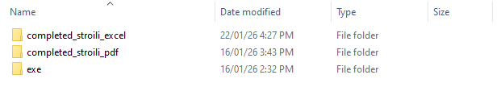
Path: D:\PO-RPA\Thoms_stroili

The PO Bot works based on a specific folder structure.
Users must place their PO files at path D:\PO-RPA\Thoms_stroili with naming convention OrderType-CustomerId-PONumber.pdf

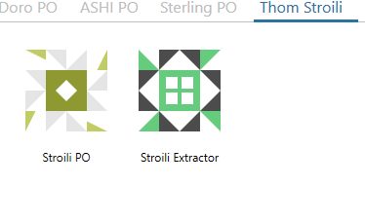
IBM RPA Launcher

- Launch the IBM RPA launcher
- Search for Thom Stroili
- There will be 2 button:
  - Stroili Extractor
  - Stroili Po
- Double click on the Stroili to convert PDF to Excel
Note: Be sure that Thom Sas PO should be present at location D:\PO-RPA\Thoms_stroili
- Users need to input their EMR ID press Enter and then EMR password
- Bot will extracted excel from pdf file and store at D:\PO-RPA
- There will be two excels
  - With naming OrderType-CustomerId-PONumber.xlsx -> Mined/Natural
  - OrderType-CustomerId-PONumber_lab_grown.xlsx -> Lab
- Extracted pdf will be moved to D:\PO-RPA\completed_stoili_pdf
- Double click on another button Stroili Po
- Bot will start running. Make sure to keep the EMR window open don’t minimize it
- Once the Data is entered into EMR, the Stroili PO will be moved to D:\PO-RPA\completed_stroili_excel

Warren James PO Bot

Folder Structure
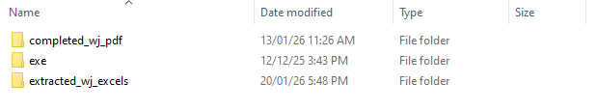
Path: D:\PO-RPA\WJ

The PO Bot works based on a specific folder structure.
Users must place their PO files at path D:\PO-RPA\WJ

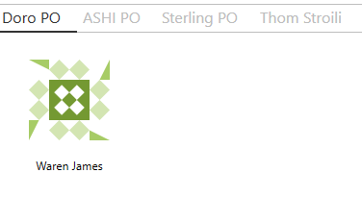
IBM RPA Launcher

- Launch the IBM RPA launcher
- Search for Warren James PO
- Double click on the button
Note: Be sure that Sterling PO should be present at location D:\PO-RPA\WJ
- Users need to input their EMR ID press Enter and then EMR password
- Bot will extracted excel from pdf file and store at D:\PO-RPA\extracted_wj_excels
- Bot will start running. Make sure to keep the EMR window open don’t minimize it
- PO containing CERT style code needed to be enter separate. For that, Input box will pop up for Order Type & Customer ID
- Once user input Order type & Customer ID new entry for CERT order will get start
- Once the Data is entered into EMR, the Warren James PO will be moved to D:\PO-RPA\completed_wj_pdf

Walmart PO Bot

Folder Structure
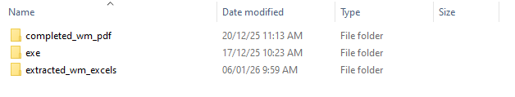
Path: D:\PO-RPA\WM
The PO Bot works based on a specific folder structure.
Users must place their PO files at path D:\PO-RPA\WM

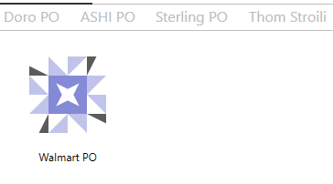
IBM RPA Launcher

- Launch the IBM RPA launcher
- Search for Walmart PO
- Double click on the button
Note: Be sure that Walmart PO should be present at location D:\PO-RPA\WM
- Users need to input their EMR ID press Enter and then EMR password
- Bot will extracted excel from pdf file and store at D:\PO-RPA\extracted_wm_excels
- Bot will start running. Make sure to keep the EMR window open don’t minimize it
- Once the Data is entered into EMR, the Walmart PO will be moved to D:\PO-RPA\completed_wm_pdf

Launcher Issue

  - ## While running the launcher for any reason if you want to stop the launcher
- Open the Task Manager and search for WDG.Automation.Launcher and click End task
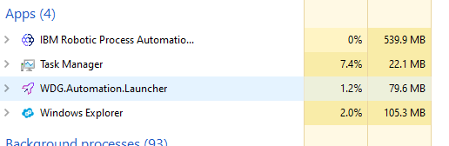

- Also scroll down in task manager and search for WDG.Automation.AgentHost and End Task all
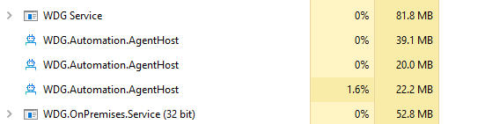
- Now again launch the IBM RPA Launcher.
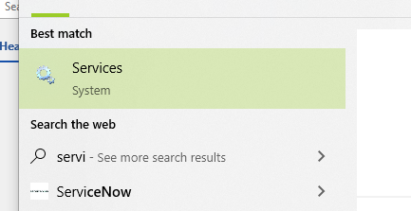
- If IBM RPA Launcher is taking long time to open search Services

- Search for IBM Robotic Process Automation service and start if stop / restart
